Optimizing Foundation Models
- Retrieval-Augmented Generation
The business case of AnyCompany illustrated how FMs are not enough to provide qualified outputs on their own. In this lesson, you will learn the Retrieval-Augmented Generation (RAG) approach that allows FMs to query knowledge bases to provide accurate and up-to-date answers to customer prompts.
From dataset to vector embeddings
LLMs (like ChatGPT) are trained on general data, so:
👉 they don’t know your company’s private data

🏢 What enterprises do
Companies have their own data:
- documents
- reports
- manuals
- internal info
👉 This data is not inside the model

💡 Solution
Instead of retraining the model, they:
👉 send relevant company data along with the user’s question
So the model gets:
User question + relevant company data → better answer

🔍 How do they find “relevant data”?
They:
- Convert text into vector embeddings (numbers)
- Search for similar meaning (not exact words)
- Retrieve the most relevant documents

🎯 Final meaning in one line
👉 “Give the model the right company data at the time of asking, so it can give accurate, customized answers.”
Vector embeddings
Embedding is the process by which text, images, and audio are given numerical representation in a vector space. Embedding is usually performed by a machine learning (ML) model. The following diagram provides more details about embedding.
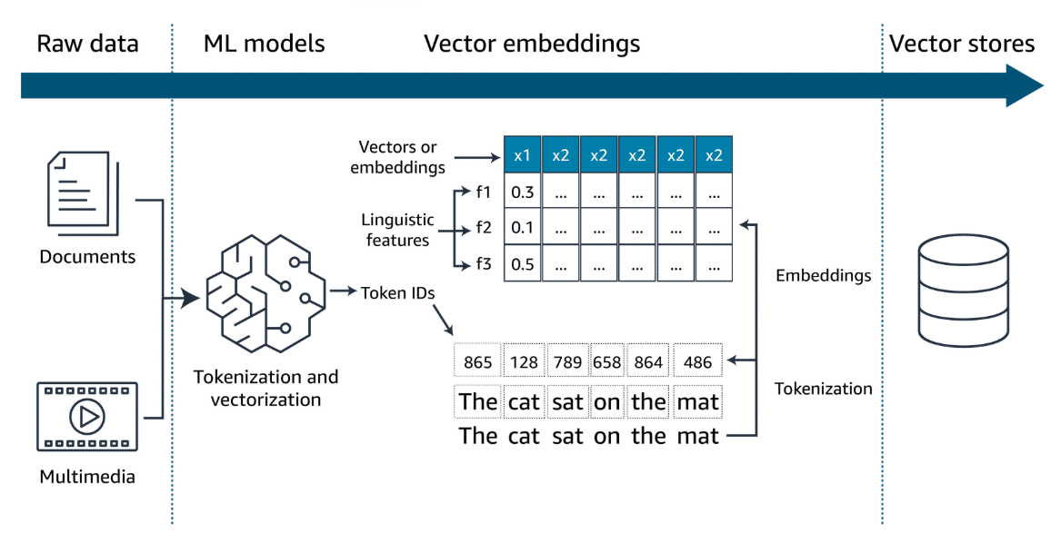
Enterprise datasets, such as documents, images and audio, are passed to ML models as tokens and are vectorized. These vectors in an n-dimensional space, along with the metadata about them, are stored in purpose-built vector databases for faster retrieval.

Storing Vectors
The core function of vector databases is to compactly store billions of high-dimensional vectors representing words and entities. Vector databases provide ultra-fast similarity searches across these billions of vectors in real time.
The most common algorithms used to perform the similarity search are k-nearest neighbors (k-NN) or cosine similarity.
Agents
Agents can serve different roles in a generative AI application, such as the following:
- Intermediary operations: Agents can act as intermediaries, facilitating communication between the generative AI model and various backend systems. The generative AI model handles language understanding and response generation. The various backend systems include items such as databases, CRM platforms, or service management tools.
- Actions launch: Agents can be used to run a wide variety of tasks. These tasks might include adjusting service settings, processing transactions, retrieving documents, and more. These actions are based on the users' specific needs understood by the generative AI model.
- Feedback integration: Agents can also contribute to the AI system's learning process by collecting data on the outcomes of their actions. This feedback helps refine the AI model, enhancing its accuracy and effectiveness in future interactions.
Evaluate results
Human evaluation
Human evaluation involves real users interacting with the AI model to provide feedback based on their experience. This method is particularly valuable for assessing qualitative aspects of the model, such as the following:
- User experience: How intuitive and satisfying is the interaction with the model from the user's perspective?
- Contextual appropriateness: Does the model respond in a way that is contextually relevant and sensitive to the nuances of human communication?
- Creativity and flexibility: How well does the model handle unexpected queries or complex scenarios that require a nuanced understanding?
Human evaluation is often used for iterative improvements and tuning the model to better meet user expectations.
Benchmark datasets
Benchmark datasets, on the other hand, provide a quantitative way to evaluate generative AI models. These datasets consist of predefined datasets and associated metrics that offer a consistent, objective means to measure model performances. This might include the following:
- Accuracy: How accurately does the model perform specific tasks according to predefined standards?
- Speed and efficiency: How quickly does the mode generate responses and how does this impact operational efficiency?
- Scalability: Can the mode maintain its performance as the scale of data or number of users increases?
Benchmark datasets are particularly useful for initial testing phases to ensure that the model meets certain technical specifications before it is put through more subjective human evaluations. They are also essential for comparing performance across different models or different iterations of the same model.
Creating a benchmark dataset:
Step 1: Create relevant questions
First, subject matter experts (SMEs) create relevant and challenging questions related to the topic of interest or specific documents.
Step 2: Context identification
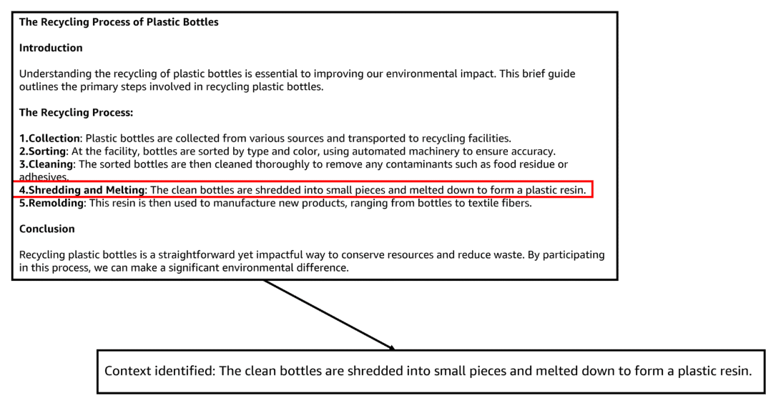
SMEs identify pertinent sections of the documents that provide context necessary for generating answers.
Step 4: Answer drafting
SMEs draft precise answers, which become the benchmark for evaluating the RAG system's responses.

Summary
Creating a benchmark dataset is a manual process that is necessary to properly evaluate LLM performances using RAG systems.
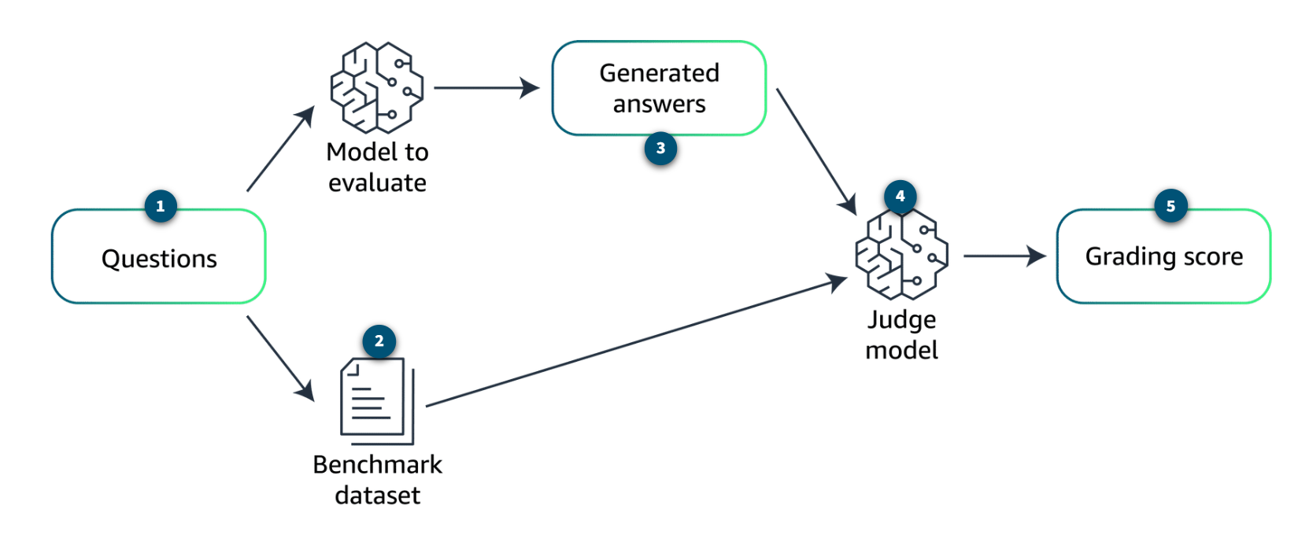
Questions
A list of questions is used to create a benchmark dataset. The same list of questions is then provided to the model for performance evaluation.
Benchmark dataset
The benchmark dataset contains both the answers and context provided by the SMEs.
Generated answers
Based on the question list, the model generates answers.
The judge model
The judge model is an external model that is used to compare the answers from the SMEs available in the benchmark dataset against the answers generated by the model to evaluate.
Grading score
The judge model calculates a grading score to assess the performance of the model. This score should take in to account metrics such as accuracy (correctness of the response), relevance (suitability of the response to the question), and comprehensiveness (depth and breadth of the response).

Combined approach
In practice, a combination of both human evaluation and benchmark datasets is often used to provide a comprehensive overview of a model's performance. Although benchmark datasets can quantify the model's technical capabilities, human evaluation brings an essential human-centric perspective that benchmarks cannot capture alone. This combined approach ensures that the model is not only technically proficient but also effective and engaging in real-world scenarios.

Fine Tuning
Although foundation models are highly versatile, they often require fine-tuning to tailor their broad capabilities to specific applications or to enhance their performance in particular domains. Fine-tuning is critical because it helps to do the following:
- Increase specificity: Adapt the model’s responses or predictions to the nuances of a specific domain or task that were not adequately covered in the initial training.
- Improve accuracy: Enhance the model's performance on specialized tasks by training on domain-specific data, thereby reducing errors that occur due to the generic nature of foundational training.
- Reduce biases: Address and mitigate any biases inherent in the initial training data, making the model fairer and more appropriate for different applications.
- Boost efficiency: Streamline the model’s operations within specific contexts, potentially reducing computational requirements and speeding up response times.
The different fine-tuning approaches
- Instruction tuning: This approach involves retraining the model on a new dataset that consists of prompts followed by the desired outputs. This is structured in a way that the model learns to follow specific instructions better. This method is particularly useful for improving the model's ability to understand and execute user commands accurately, making it highly effective for interactive applications like virtual assistants and chatbots.
- Reinforcement learning from human feedback (RLHF): This approach is a fine-tuning technique where the model is initially trained using supervised learning to predict human-like responses. Then, it is further refined through a reinforcement learning process, where a reward model built from human feedback guides the model toward generating more preferable outputs. This method is effective in aligning the model’s outputs with human values and preferences, thereby increasing its practical utility in sensitive applications.
- Adapting models for specific domains: This approach involves fine-tuning the model on a corpus of text or data that is specific to a particular industry or sector. An example of this would be legal documents for a legal AI or medical records for a healthcare AI. This specificity enables the model to perform with a higher degree of relevance and accuracy in domain-specific tasks, providing more useful and context-aware responses.
- Transfer learning: This approach is a method where a model developed for one task is reused as the starting point for a model on a second task. For foundational models, this often means taking a model that has been trained on a vast, general dataset, then fine-tuning it on a smaller, specific dataset. This method is highly efficient in using learned features and knowledge from the general training phase and applying them to a narrower scope with less additional training required.
- Continuous pretraining: This approach involves extending the training phase of a pre-trained model by continuously feeding it new and emerging data. This approach is used to keep the model updated with the latest information, vocabulary, trends, or research findings, ensuring its outputs remain relevant and accurate over time.
Preparing the data for the fine-tuning step
During the initial training phase, a foundational model is trained on a vast and diverse dataset. This dataset typically encompasses a wide range of topics to develop a broad understanding and general capabilities. The goals during this phase are as follows:
- Extensive coverage: Ensuring the dataset covers a broad spectrum of knowledge to give the model a robust foundational understanding
- Diversity: Including varied types of data from numerous sources to equip the model with the ability to handle a wide array of tasks
- Generalization: Focusing on building a model that can generalize across different tasks and domains without specific tailoring
Data preparation for this phase involves collecting as much data as possible. The data is often from publicly available sources, curated datasets, and sometimes proprietary data, depending on the model's intended usage. The data needs thorough cleaning and possibly anonymization to ensure privacy and compliance with regulations.
Data preparation for fine-tuning
Fine-tuning, on the other hand, is a more targeted process where a pretrained model is adapted to perform well on a specific task or within a particular domain. The data preparation for fine-tuning is distinct from initial training due to the following reasons:
- Specificity: The dataset for fine-tuning is much more focused, containing examples that are directly relevant to the specific tasks or problems the model needs to solve.
- High relevance: Data must be highly relevant to the desired outputs. Examples include legal documents for a legal AI or customer service interactions for a customer support AI.
- Quality over quantity: Although the initial training requires massive amounts of data, fine-tuning can often achieve significant improvements with much smaller, but well-curated datasets.
Key steps in fine-tuning data preparation
- Data curation: Although it is a continuation, this involves a more rigorous selection process to ensure every piece of data is highly relevant. This step also ensures the data contributes to the model's learning in the specific context.
- Labeling: In fine-tuning, the accuracy and relevance of labels are paramount. They guide the model's adjustments to specialize in the target domain.
- Governance and compliance: Considering fine-tuning often uses more specialized data, ensuring data governance and compliance with industry-specific regulations is critical.
- Representativeness and bias checking: It is essential to ensure that the fine-tuning dataset does not introduce or perpetuate biases that could skew the model's performance in undesirable ways.
- Feedback integration: For methods like RLHF, incorporating user or expert feedback directly into the training process is crucial. This is more nuanced and interactive than the initial training phase.

Model evaluation
ROUGE
ROUGE = “How much overlap is there between generated summary and the correct (human) summary?”
ROUGE is a set of metrics used to evaluate automatic summarization of texts, in addition to machine translation quality in NLP. The main idea behind ROUGE is to count the number of overlapping units. This includes words, N-grams, or sentence fragments between the computer-generated output and a set of reference (human-created) texts.
The following are two ways to use the ROUGE metric:
- ROUGE-N: This metric measures the overlap of n-grams between the generated text and the reference text. For example, ROUGE-1 refers to the overlap of unigrams, ROUGE-2 refers to bigrams, and so on. This metric primarily assesses the fluency of the text and the extent to which it includes key ideas from the reference.
- ROUGE-L: This metric uses the longest common subsequence between the generated text and the reference texts. It is particularly good at evaluating the coherence and order of the narrative in the outputs.
ROUGE is widely used because it is not complex. It is interpretable, and correlates reasonably well with human judgment, especially when evaluating the recall aspect of summaries. The evaluations assess how much of the important information in the source texts is captured by the generated summaries.
Reference (Human summary)
“The cat sat on the mat.”
🤖 Generated Summary
“The cat is on the mat.”

- 🔹 1. ROUGE-N (Word Overlap)
👉 ROUGE-1 (Single words)
Break into words:
- Reference:
the, cat, sat, on, the, mat
- Generated:
the, cat, is, on, the, mat
✅ Common words:
the, cat, on, the, mat → 5 matches
📊 ROUGE-1 Recall:
= (overlapping words) / (total words in reference)
= 5 / 6 ≈ 0.83
👉 Meaning:
83% of important words from the real summary are captured

👉 ROUGE-2 (Word pairs)
Reference bigrams:
- the cat
- cat sat
- sat on
- on the
- the mat
Generated bigrams:
- the cat
- cat is
- is on
- on the
- the mat
✅ Matches:
- the cat
- on the
- the mat → 3 matches
📊 ROUGE-2:
= 3 / 5 = 0.6
👉 Meaning:
Some structure is preserved, but not perfectly
- 2. ROUGE-L (Longest Common Sequence)
Now we care about order and flow.
Longest common subsequence:
the cat on the mat
(length = 5)
📊 ROUGE-L:
= 5 / 6 ≈ 0.83
👉 Meaning:
- The sentence structure is mostly preserved
- Only one word ("sat") was replaced

BLEU
BLEU = “How much of your generated sentence is correct compared to the reference?”
BLEU is a metric used to evaluate the quality of text that has been machine-translated from one natural language to another. Quality is calculated by comparing the machine-generated text to one or more high-quality human translations. BLEU measures the precision of N-grams in the machine-generated text that appears in the reference texts and applies a penalty for overly short translations (brevity penalty).
Unlike ROUGE, which focuses on recall, BLEU is fundamentally a precision metric. It checks how many words or phrases in the machine translation appear in the reference translations. BLEU evaluates the quality at the level of the sentence, typically using a combination of unigrams, bigrams, trigrams, and quadrigrams. A brevity penalty discourages overly concise translations that might influence the precision score.
BLEU is popular in the field of machine translation for its ease of use and effectiveness at a broad scale. However, it has limitations in assessing the fluency and grammaticality of the output.
The BERTScore
BERTScore = “Even if the words are different, do both sentences convey the same meaning?”
BERTScore uses the pretrained contextual embeddings from models like BERT to evaluate the quality of text-generation tasks. BERTScore computes the cosine similarity between the contextual embeddings of words in the candidate and the reference texts. This is unlike traditional metrics that rely on exact matches of N-grams or words.
Because BERTScore evaluates the semantic similarity rather than relying on exact lexical matches, it is capable of capturing meaning in a more nuanced manner. BERTScore is less prone to some of the pitfalls of BLEU and ROUGE. An example of this is their sensitivity to minor paraphrasing or synonym usage that does not affect the overall meaning conveyed by the text.
BERTScore is increasingly used alongside traditional metrics like BLEU and ROUGE for a more comprehensive assessment of language generation models. This is especially true in cases where capturing the deeper semantic meaning of the text is important.

Machine Translation → BLEU
Summarization → ROUGE
Meaning-sensitive tasks → BERTScore

